**Project Design Phase**

**Problem – Solution Fit Template**

|  |  |
| --- | --- |
| Date | 27 – June-2025 |
| Team ID | LTVIP2025TMID30752 |
| Project Name | Sustainable Smart City Assistant Using IBM Granite LLM |
| Maximum Marks | 2 Marks |

**Problem – Solution Fit Template:**

**Project Title:**

**Sustainable Smart City Assistant Using IBM WatsonX**

**What’s the Real Problem?**

Modern cities face multiple overlapping challenges:

* **Environmental stress** (e.g. energy/water overuse, carbon emissions).
* **Complex and inaccessible urban policy documents**.
* **Low citizen engagement** in sustainability governance.
* **Lack of predictive tools** to support city infrastructure planning.
* **Unstructured feedback reporting** by residents.
* **No way to semantically search through government documentation**.

**Target Audience / Stakeholders**

* Municipal government departments (urban planning, water, energy).
* Citizens and sustainability activists.
* School/university educators raising eco-awareness.
* IT departments building smart city dashboards.

**Our Solution (What we built)**

An **AI-powered Smart City Assistant** that:

* Uses **IBM WatsonX LLM (Granite)** to **summarize policy documents**.
* Provides a **chat assistant** that answers citizen sustainability queries.
* Forecasts city KPIs like **energy/water use** from CSV files.
* Detects **anomalies in resource usage**.
* Generates **eco-friendly tips** based on topic keywords.
* Accepts **citizen feedback** via forms and logs them.
* Performs **semantic document search** using Pinecone.

**Purpose:**

**❑ Solve complex urban sustainability and governance issues in ways that fit both city planners and citizens.**

**❑ Accelerate adoption by integrating familiar channels like dashboards, forms, CSV uploads, and document support.**

**❑ Sharpen city communication by converting dense policy documents into AI-friendly summaries.**

**❑ Build trust and engagement by solving common pain points like feedback submission and policy access.**

**❑ Understand current city operational gaps and help improve them through AI-based forecasting and anomaly detection.**

**Template:**

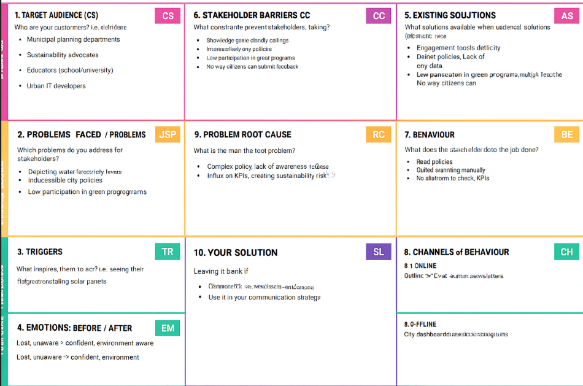

References:

1. <https://www.ideahackers.network/problem-solution-fit-canvas/>
2. <https://medium.com/@epicantus/problem-solution-fit-canvas-aa3dd59cb4fe>